

**Elementary and K-8 Schools**

**Tuesday August 2nd, 2021**

**12 pm-6 pm**

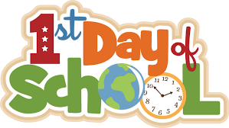

**Thursday, August 5th, 2021**